POE PART.2.

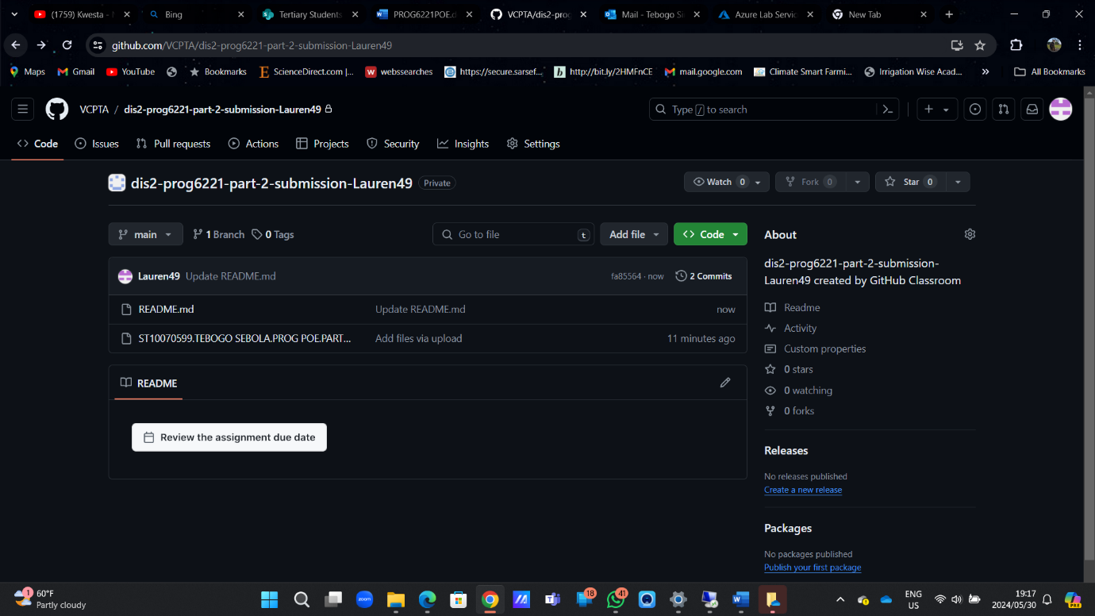

https://github.com/VCPTA/dis2-prog6221-part-2-submission-Lauren49